**Review Worksheet: DNA sequencing and Protein Electrophoresis**

**Name: ……………………………………………………………..**

*Do these questions, using your learning resources. Look at the “marks” to give you an idea of the level of detail required in the response (formative only – does not count towards your grade). At the end, mark your work, correct it, and fill in the reflection section. Questions marked * require you to use reasoning, inferring and application of knowledge, or perhaps extra research to get the answer. It won’t be right there in the text.*

1: How do nucleotides chemically bind to the one before them as they are added to a sequence by DNA polymerase?

(3 marks)

*………………………………………………………………………………………………………………….*

*………………………………………………………………………………………………………………….*

*………………………………………………………………………………………………………………….*

2: Nucleotides are also known as dNTPs in the Sanger sequencing technique. The technique also involves ddNTPs. What is the structural difference between dNTP and ddNTP and what effect does it have on the sequencing process.

(5 marks)

*………………………………………………………………………………………………………………….*

*………………………………………………………………………………………………………………….*

*………………………………………………………………………………………………………………….*

*………………………………………………………………………………………………………………….*

*………………………………………………………………………………………………………………….*

*………………………………………………………………………………………………………………….*

3: What are the ingredients involved in Sanger DNA sequencing and what is the role of each?

(5 marks)

*………………………………………………………………………………………………………………….*

*………………………………………………………………………………………………………………….*

*………………………………………………………………………………………………………………….*

*………………………………………………………………………………………………………………….*

*………………………………………………………………………………………………………………….*

*………………………………………………………………………………………………………………….*

4: Four reaction mixtures are set up in Sanger DNA sequencing. Only one ingredient is different in each reaction mixture. Which is it, and why is it different?

(4 marks)

*………………………………………………………………………………………………………………….*

*………………………………………………………………………………………………………………….*

*………………………………………………………………………………………………………………….*

*………………………………………………………………………………………………………………….*

*………………………………………………………………………………………………………………….*

*………………………………………………………………………………………………………………….*

5: There are four wells in the electrophoresis gel used for Sanger sequencing. Why are there four wells and how does it help with sequencing?

(3 marks)

*………………………………………………………………………………………………………………….*

*………………………………………………………………………………………………………………….*

*………………………………………………………………………………………………………………….*

*………………………………………………………………………………………………………………….*

*………………………………………………………………………………………………………………….*

*………………………………………………………………………………………………………………….*

6: Describe the steps involved in Sanger sequencing:

(18 marks)

*………………………………………………………………………………………………………………….*

*………………………………………………………………………………………………………………….*

*………………………………………………………………………………………………………………….*

*………………………………………………………………………………………………………………….*

*………………………………………………………………………………………………………………….*

*………………………………………………………………………………………………………………….*

*………………………………………………………………………………………………………………….*

*………………………………………………………………………………………………………………….*

*………………………………………………………………………………………………………………….*

*………………………………………………………………………………………………………………….*

*………………………………………………………………………………………………………………….*

*………………………………………………………………………………………………………………….*

*………………………………………………………………………………………………………………….*

*………………………………………………………………………………………………………………….*

*………………………………………………………………………………………………………………….*

*………………………………………………………………………………………………………………….*

*………………………………………………………………………………………………………………….*

*………………………………………………………………………………………………………………….*

*………………………………………………………………………………………………………………….*

*………………………………………………………………………………………………………………….*

*………………………………………………………………………………………………………………….*

*………………………………………………………………………………………………………………….*

*………………………………………………………………………………………………………………….*

*………………………………………………………………………………………………………………….*

*………………………………………………………………………………………………………………….*

*………………………………………………………………………………………………………………….*

*………………………………………………………………………………………………………………….*

7: In Sanger sequencing, the terminator base addition determines the length of each strand. Protein electrophoresis is also used for DNA profiling. What is used to break the DNA into short lengths for DNA profiling?

(1 mark)

*………………………………………………………………………………………………………………….*

*………………………………………………………………………………………………………………….*



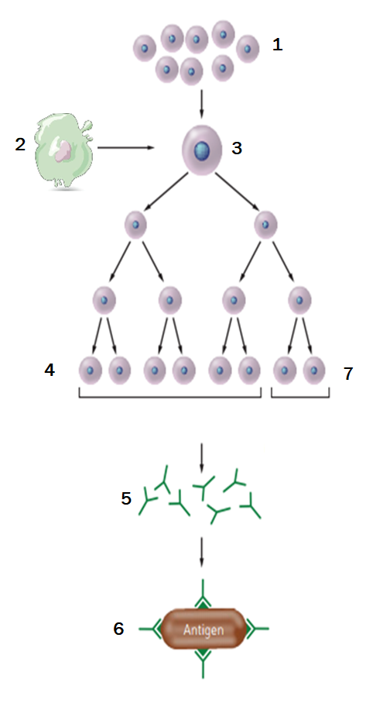8: Name the type of immunity that is occurring in the diagram below and describe what is happening at each step.   
(10 marks of 11.5 marks)

*………………………………………………………………………………………………………………….*

*………………………………………………………………………………………………………………….*

*………………………………………………………………………………………………………………….*

*………………………………………………………………………………………………………………….*

*………………………………………………………………………………………………………………….*

*………………………………………………………………………………………………………………….*

*………………………………………………………………………………………………………………….*

*………………………………………………………………………………………………………………….*

*………………………………………………………………………………………………………………….*

*………………………………………………………………………………………………………………….*

*………………………………………………………………………………………………………………….*

*………………………………………………………………………………………………………………….*

*………………………………………………………………………………………………………………….*

*………………………………………………………………………………………………………………….*

*………………………………………………………………………………………………………………….*

Go back and mark your work using the marking key provided. What score did you get? /49

*I included enough detail in my answers.*



*I was able to find information in the text/powerpoint presentation.*

*I was able to reason and infer where the information wasn’t directly in the text (questions with *).*

*I marked my work and wrote down any answers where I missed marks.*